Aaron Boyle

Dr. Chen

CS445

5 May 2020

Final Exam

1)

a)

*Using gdb to find the appropriate addresses and comparing them. Filling out buffer spacing, ebp address + 4:*  
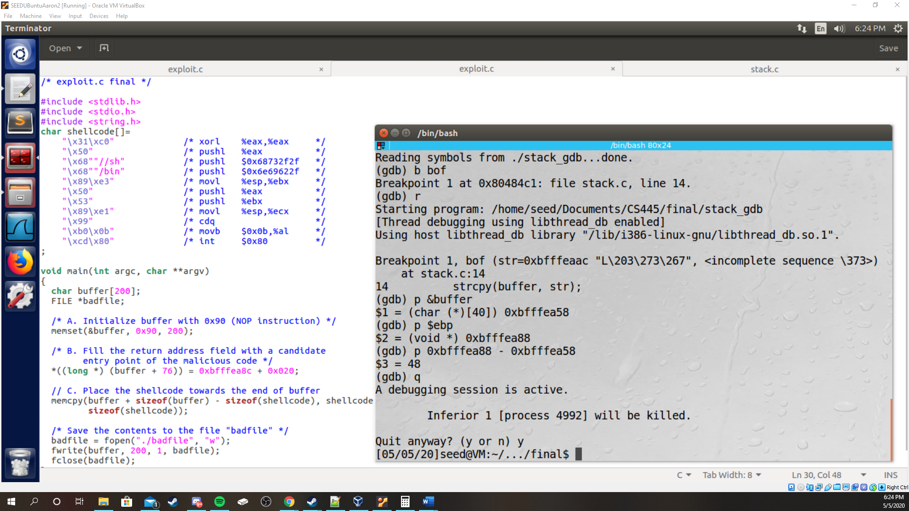 *Having some issues, still thought these were significant moments :*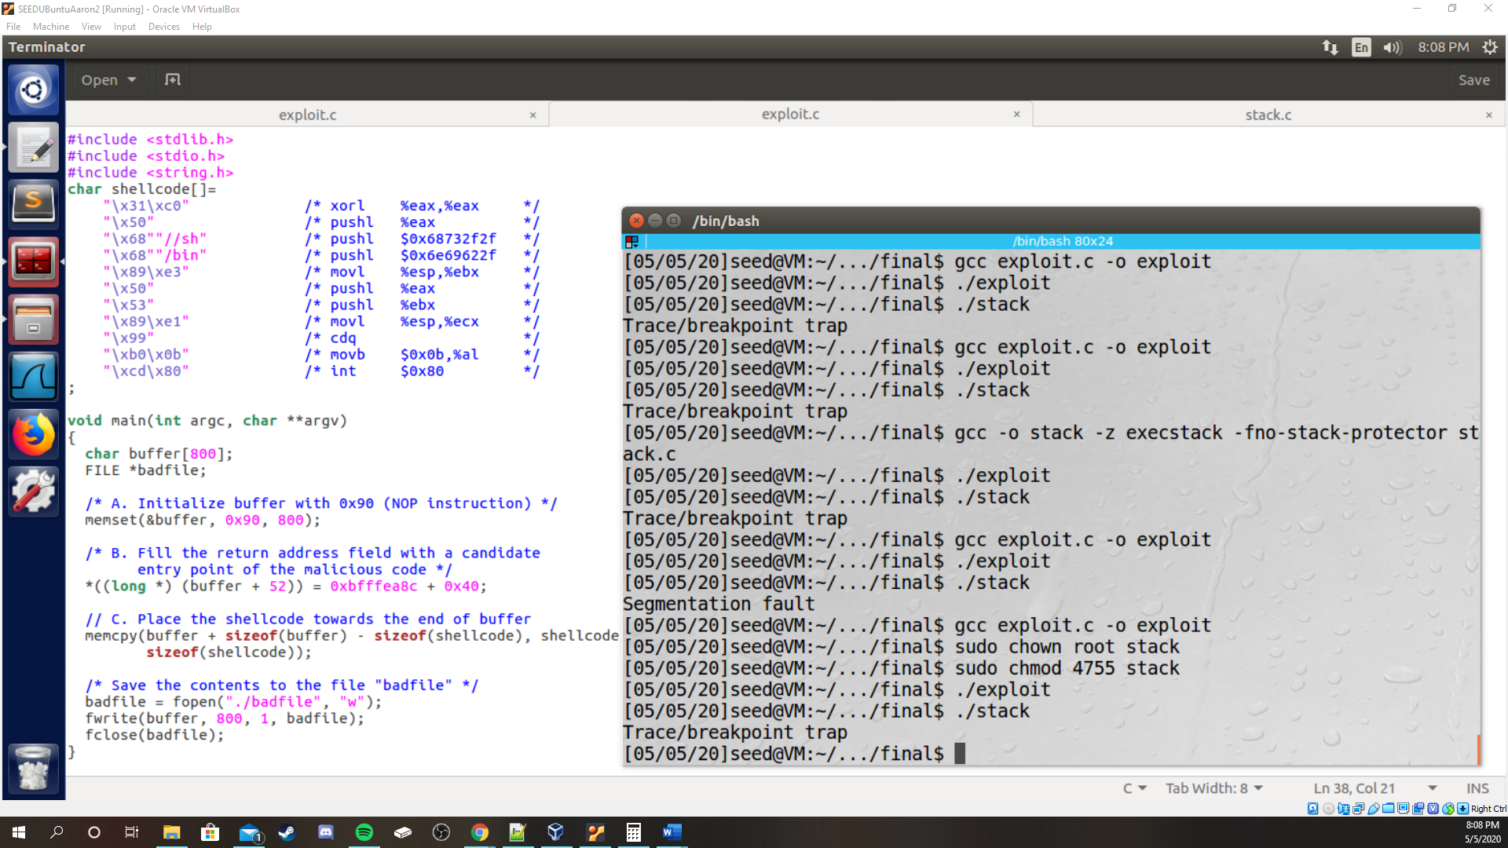

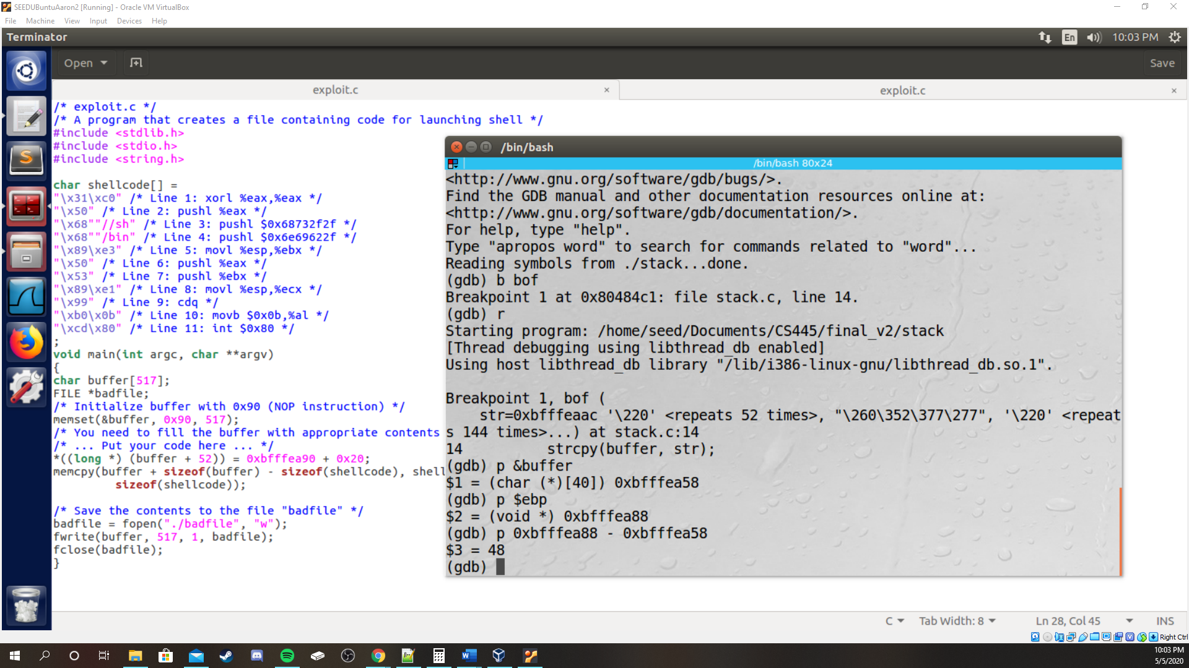

*Gaining root privilege:*

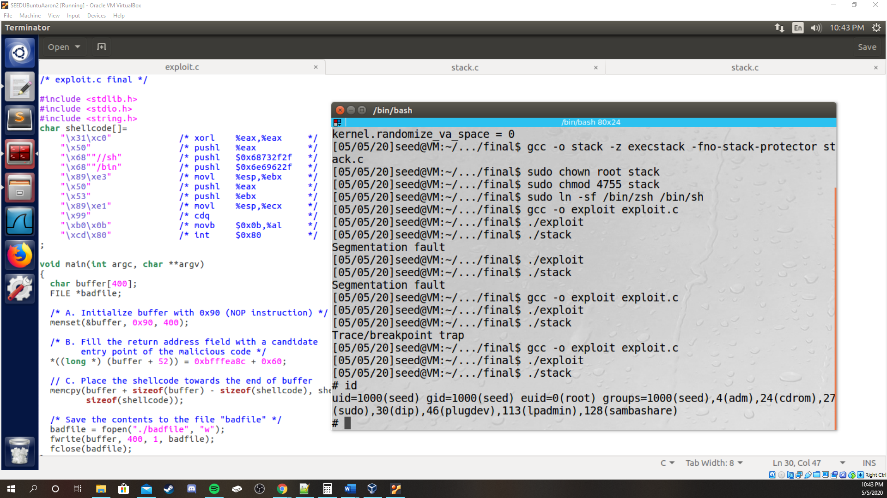

b)  
*exploit1.c code, “Hi CS445”*

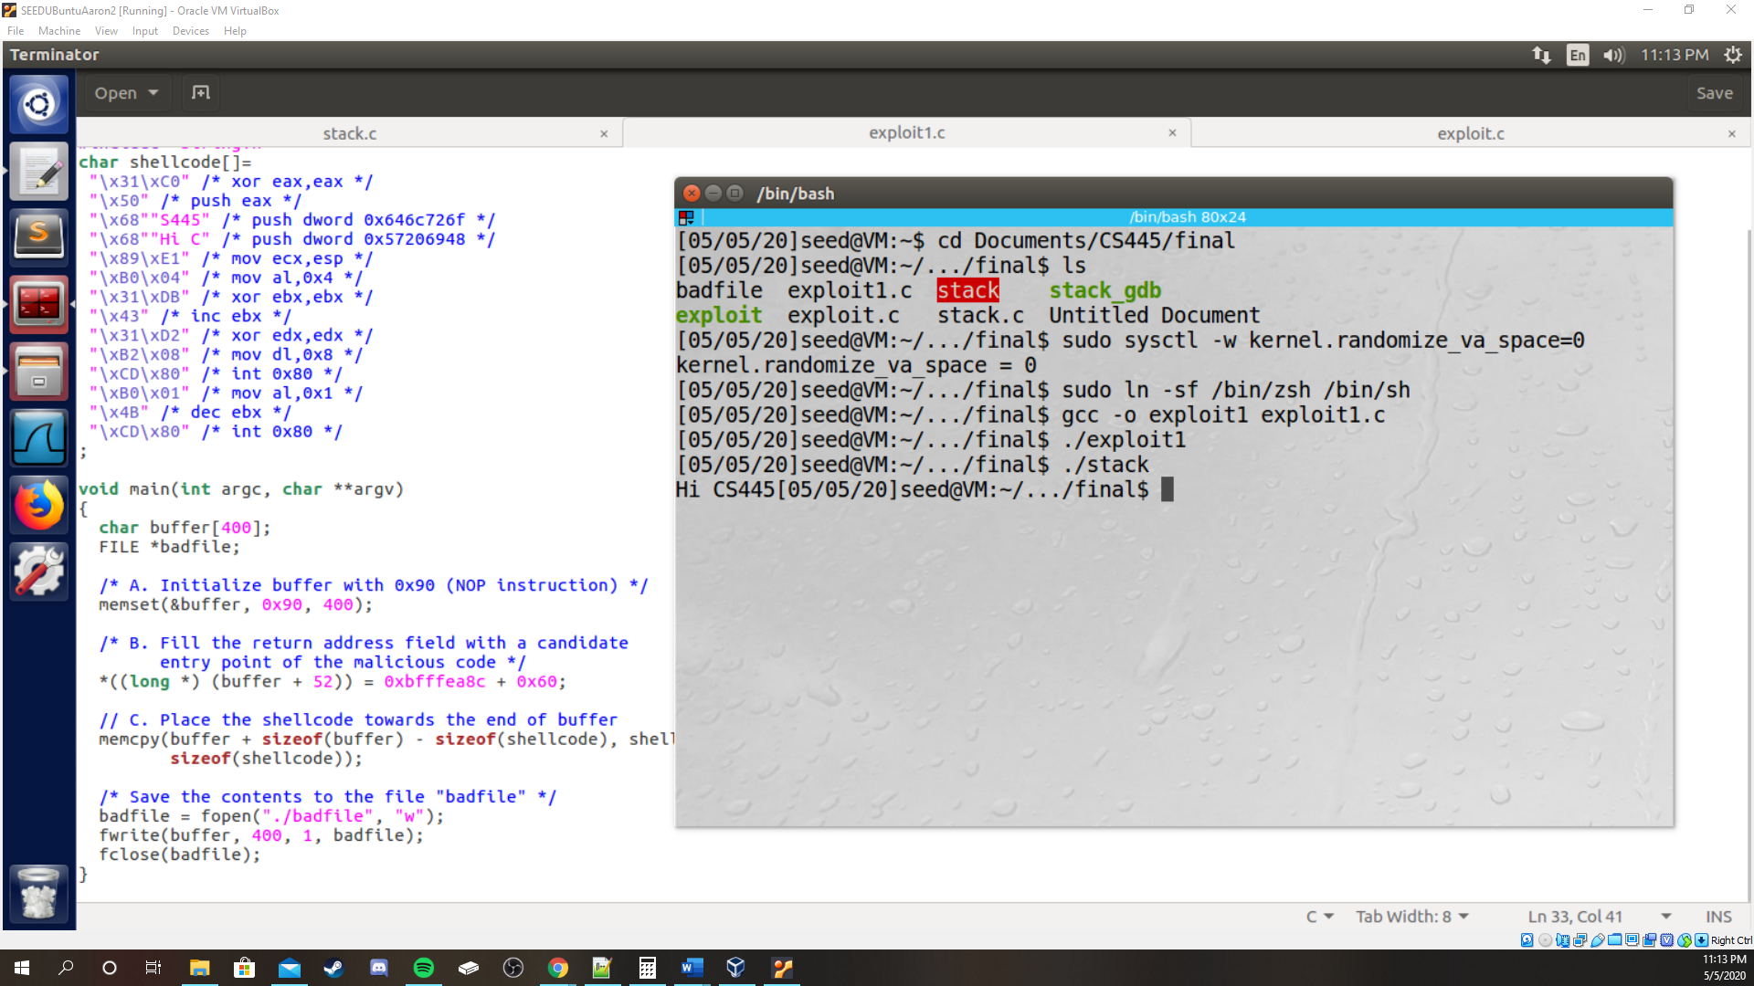

2)

*ftp-test-deleting “secret,” ftp client login:*

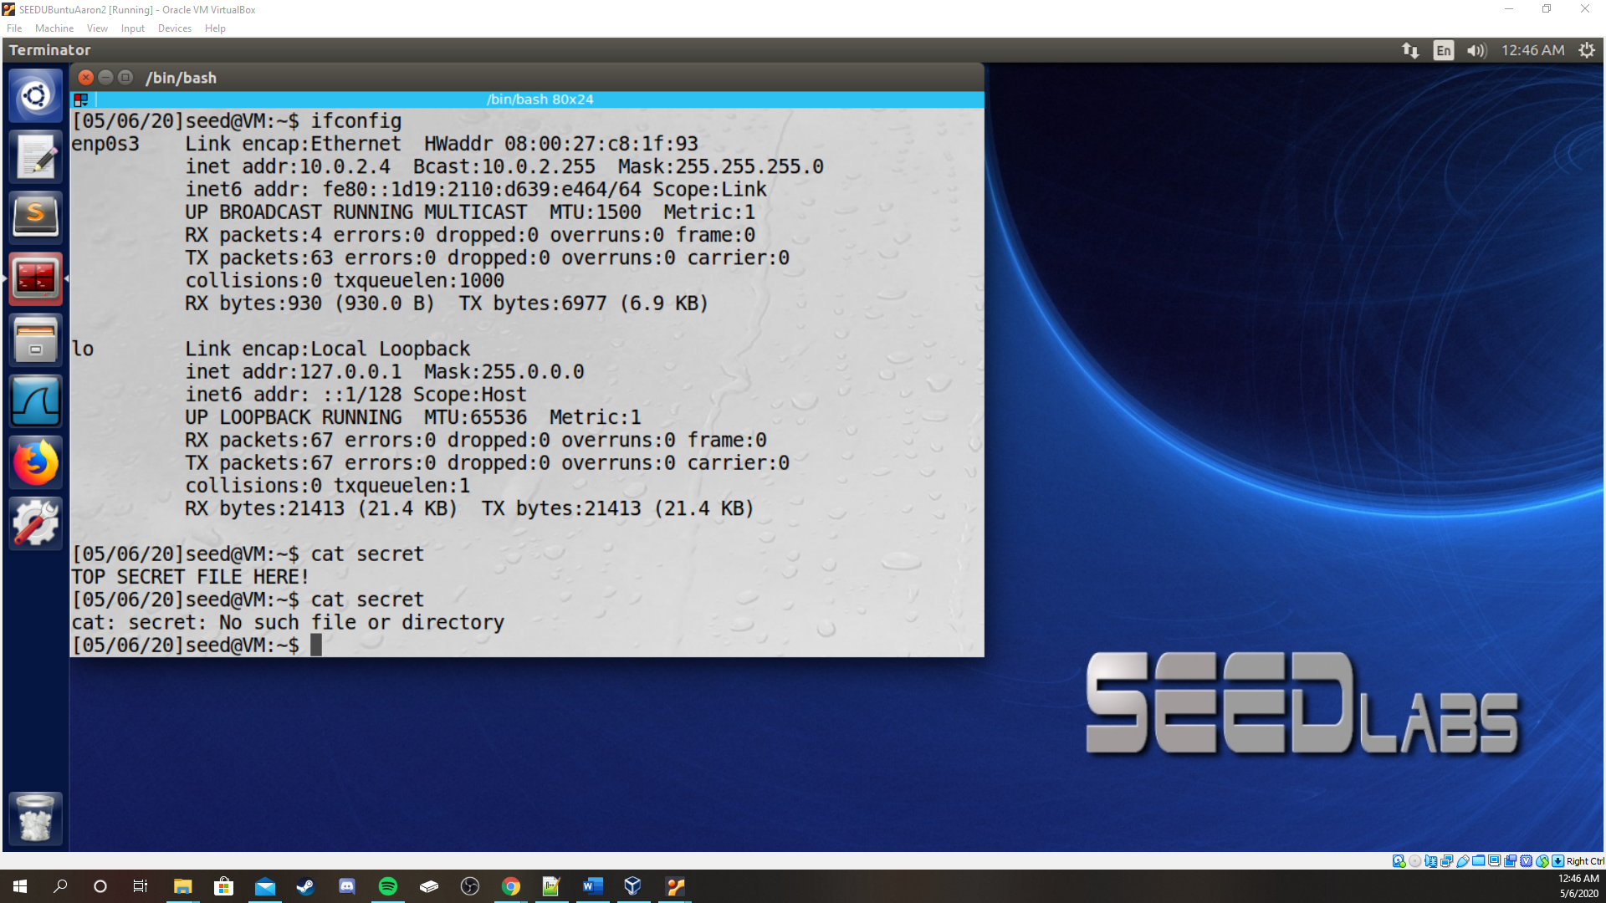  
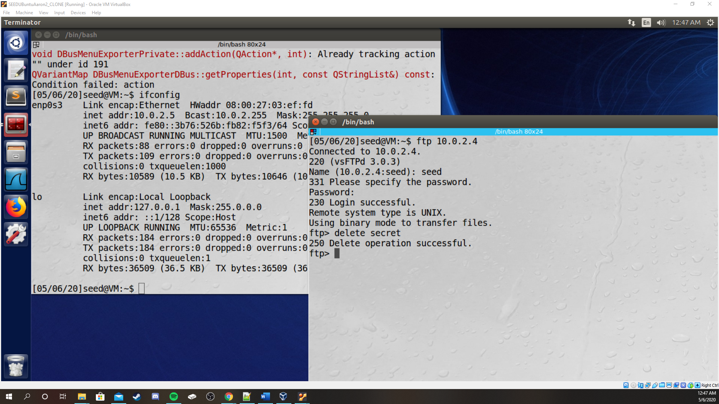

*Wiresharking ftp login packets;delete command in hex(bottom-right):  
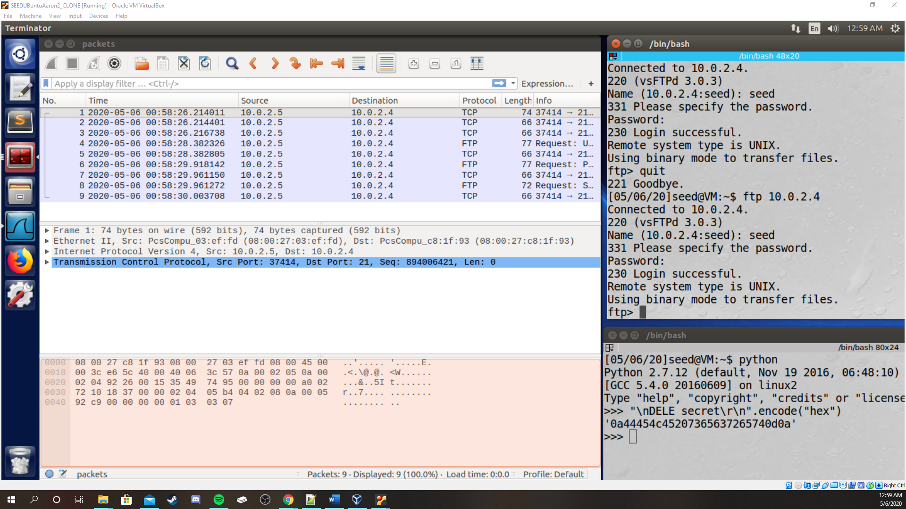  
*I had to reset the ftp connection so source port, seq. num., ack. num. have changed from previous screenshot. Also hex changed too.\**

*Deleting secret using netwox 40 on a ftp connection:  
Attacker:  
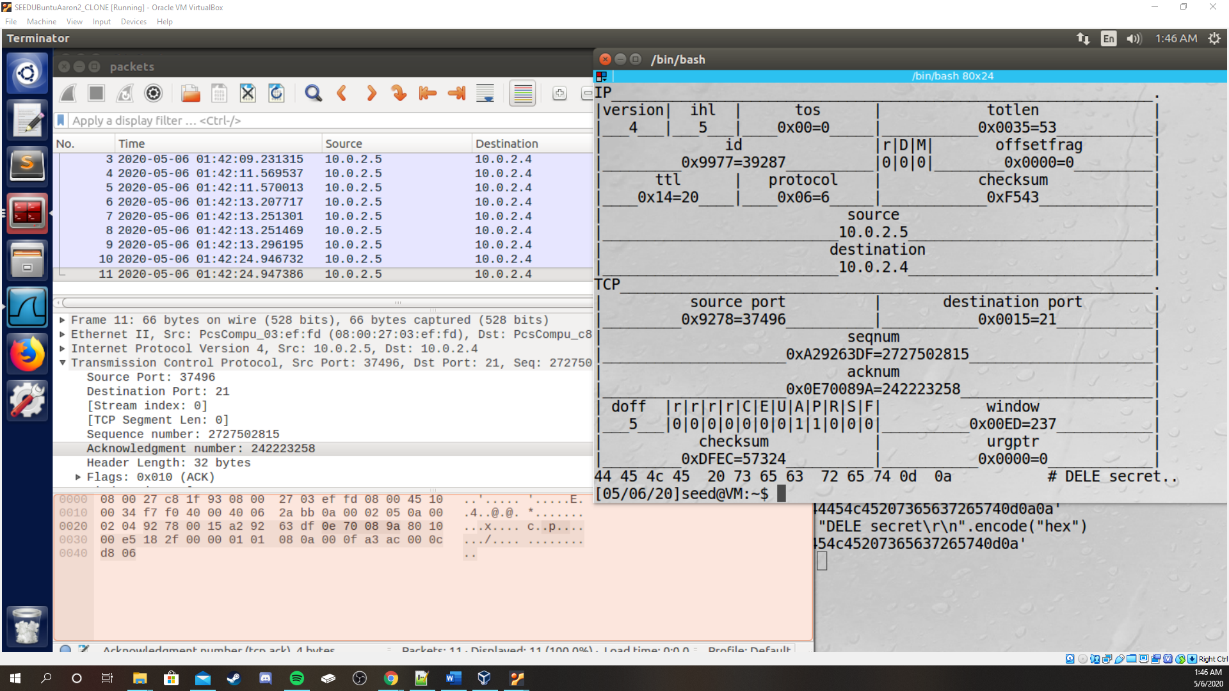  
Server:  
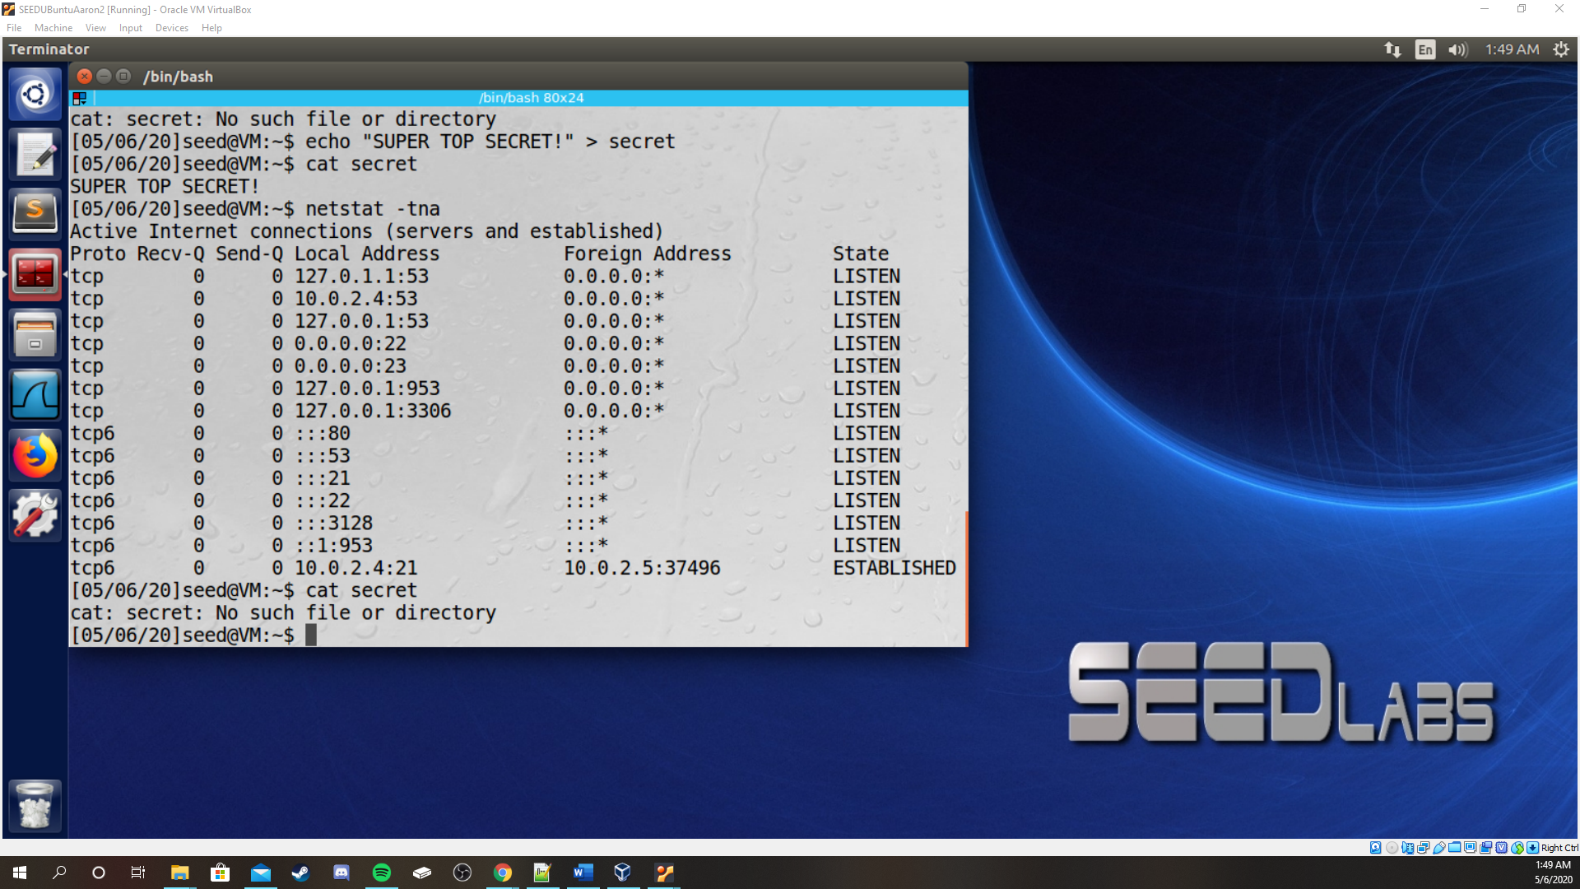*

Summary for any additional clarification:

Make sure you have ftp write privileges enabled for your server by editing the vsftpd.conf file and uncommenting “write_enable”; restart your VM; create your secret; log in via FTP and delete the file using “delete secret” to verify that write privileges are enabled; build the secret again; use tcpdump and wireshark to sniff the same packet information as usual for netwox 40; generate the hex code for “DELE secret\r\n” specifically – no need to add additional “\n”; build netwox 40 according to the information taken earlier, and don’t forget to set the *push* flag(-A) after the *ack* flag (-z), and I think that about wraps it up.

3)

Enc2.c is the file I was modifying for the dictionary attack.

The idea was to read a line out of the file, apply the padding, and copy the result to the key[][] array. Couldn’t get it to work. I don’t know the best way of managing it.

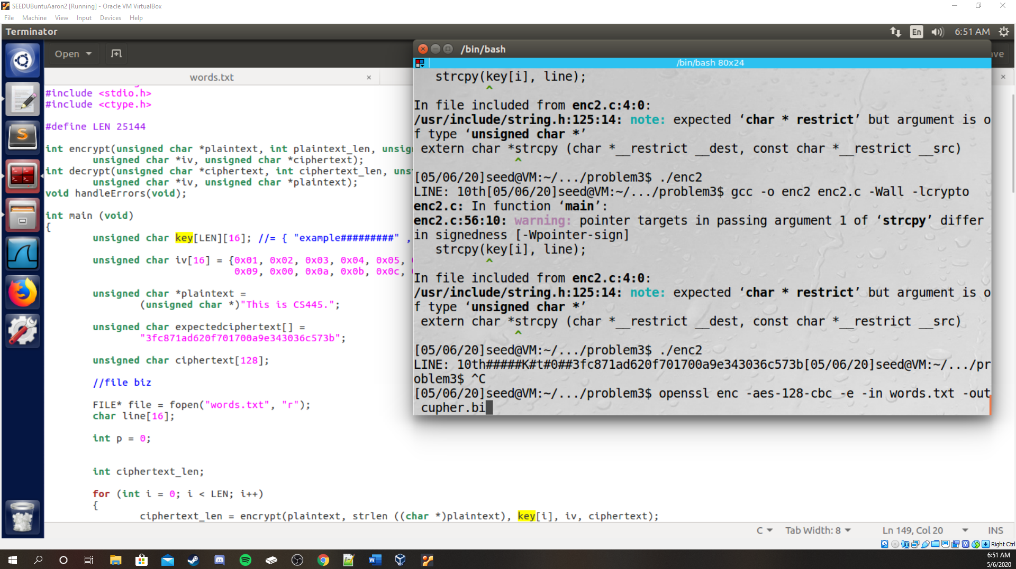

4)

a)  
*Generation:*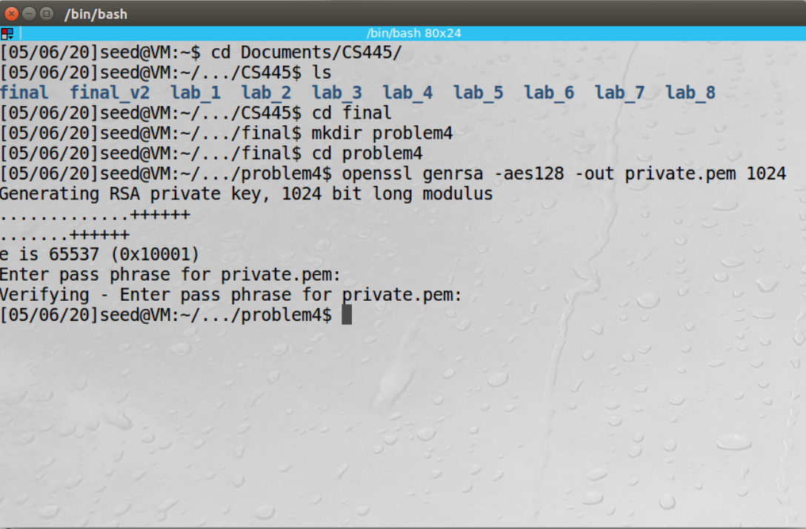  
b)

c)

d)